**Name: Purva Tagde**

**PRN:23070521111**

# Practical 06 Part II

# Introduction to Loops in PL/SQL

Loops allow repeated execution of a block of statements. PL/SQL supports three types of loops:

**BASIC LOOP** (Infinite Loop)

**WHILE LOOP** (Condition-based)

**FOR LOOP** (Counter-based)

# BASIC LOOP (Must use EXIT condition)

A LOOP executes repeatedly until an EXIT condition is met.

## Example: Print numbers from 1 to 5 using LOOP

SET SERVEROUTPUT ON;

DECLARE

i NUMBER := 1;

BEGIN

LOOP

DBMS_OUTPUT.PUT_LINE('Number: ' || i);

i := i + 1;

EXIT WHEN i > 5; -- Exit condition

END LOOP;

END; /

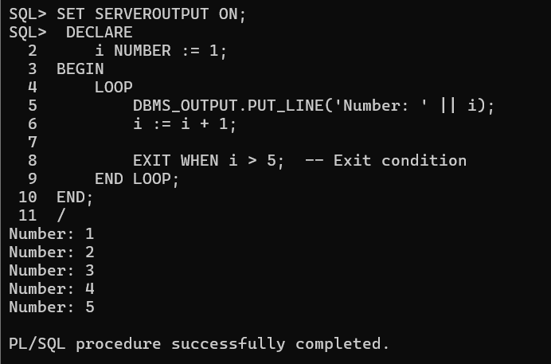

**Explanation:** The loop runs indefinitely until i becomes greater than 5.

# WHILE LOOP (Executes as long as condition is TRUE)

A WHILE loop checks a condition before executing the block.

## Example: Print numbers from 1 to 5 using WHILE LOOP

SET SERVEROUTPUT ON;

DECLARE

i NUMBER := 1;

BEGIN

WHILE i <= 5 LOOP

DBMS_OUTPUT.PUT_LINE('Number: ' || i);

i := i + 1;

END LOOP;

END; /

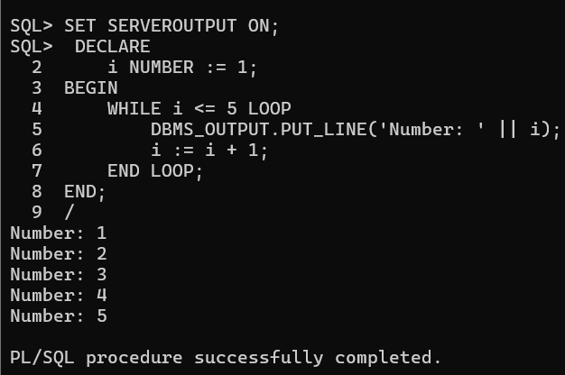

**Explanation:** The loop runs as long as i <= 5. When i becomes 6, it stops.

# FOR LOOP (Counter-based)

A FOR loop runs a fixed number of times.

## Example: Print numbers from 1 to 5 using FOR LOOP

SET SERVEROUTPUT ON;

BEGIN

FOR i IN 1..5 LOOP

DBMS_OUTPUT.PUT_LINE('Number: ' || i);

END LOOP;

END; /

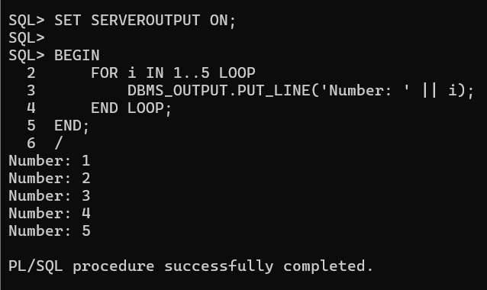 **Explanation:** The loop runs automatically from 1 to 5, eliminating the need for a manual counter.

# REVERSE FOR LOOP

A FOR loop can count **backward** using REVERSE.

## Example: Print numbers from 5 to 1 using FOR LOOP

SET SERVEROUTPUT ON;

BEGIN

FOR i IN REVERSE 1..5 LOOP

DBMS_OUTPUT.PUT_LINE('Number: ' || i);

END LOOP;

END; /

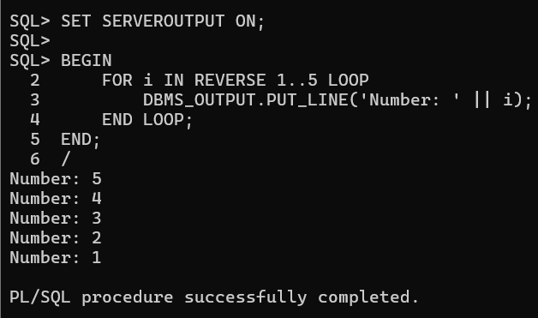

**Explanation:** The loop counts **down** from 5 to 1.

# Simple Tasks for Practice

Write a **BASIC LOOP** to print numbers from 1 to 10.

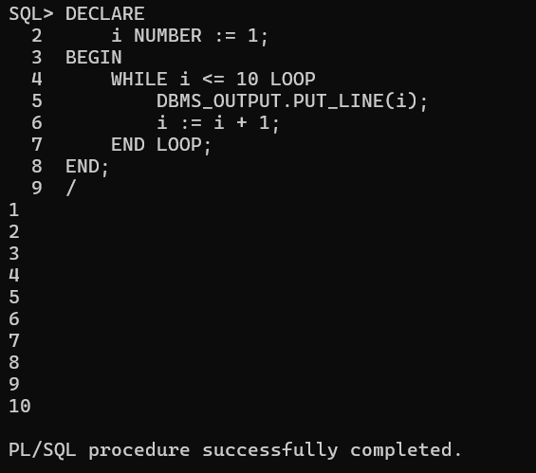

Modify the **WHILE LOOP** to print **even numbers** from 2 to 10.

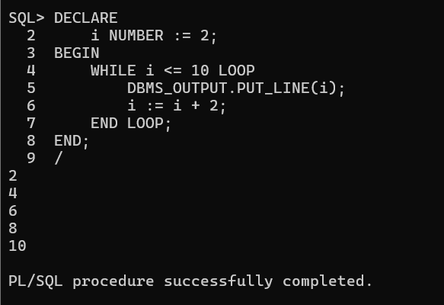

Write a **FOR LOOP** to print the **square of numbers** from 1 to 5.

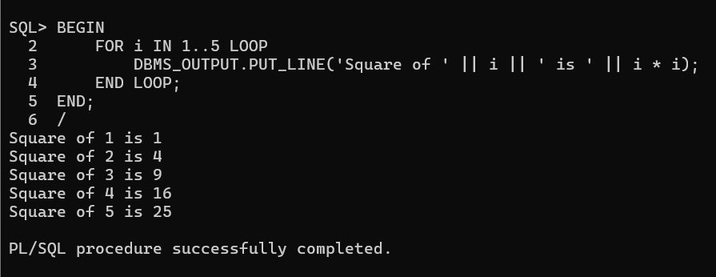

Create a **REVERSE FOR LOOP** that prints numbers from 10 to 1. Write a loop that **calculates the sum of numbers from 1 to 5**.

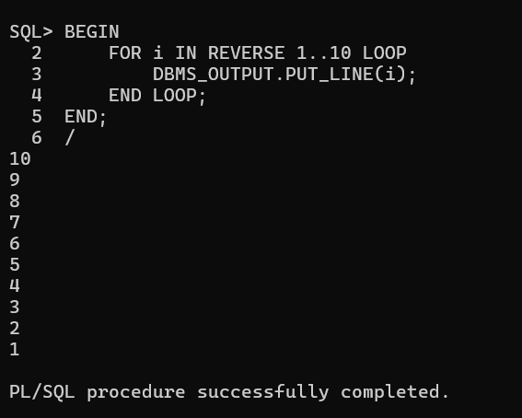

**LOOPS USECASES IN DBMS**

# BASIC LOOP (Must use EXIT condition)

The LOOP statement runs indefinitely unless explicitly stopped with an EXIT condition.

## Example 1: Insert 5 Records into a Table Using LOOP

BEGIN

FOR i IN 1..5 LOOP

INSERT INTO employees (id, name, salary) VALUES (i,

'Employee_' || i, 5000 + (i * 500));

END LOOP;

COMMIT;

END;

/

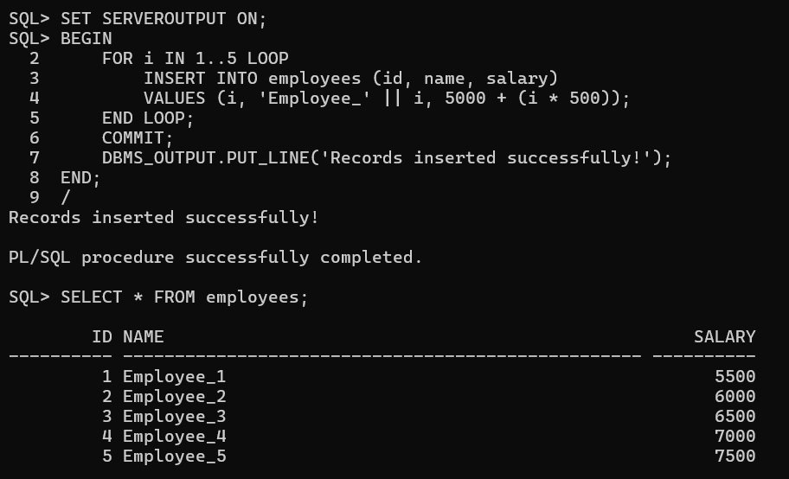

**Explanation:** Inserts 5 employees with incrementing salaries.

## Example 2: Fetch and Display Employee Names Using LOOP DECLARE v_name employees.name%TYPE;

CURSOR emp_cursor IS SELECT name FROM employees;

BEGIN

OPEN emp_cursor;

LOOP

FETCH emp_cursor INTO v_name;

EXIT WHEN emp_cursor%NOTFOUND;

DBMS_OUTPUT.PUT_LINE('Employee: ' || v_name);

END LOOP;

CLOSE emp_cursor;

END;

/

**Explanation:** Uses a cursor to fetch and print employee names one by one.

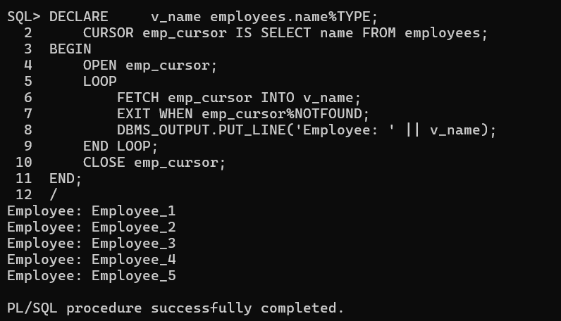

## Example 3: Delete Employees with Salary Below 3000 Using LOOP

DECLARE

CURSOR emp_cursor IS SELECT id FROM employees WHERE salary < 3000; v_id employees.id%TYPE;

BEGIN

OPEN emp_cursor;

LOOP

FETCH emp_cursor INTO v_id;

EXIT WHEN emp_cursor%NOTFOUND;

DELETE FROM employees WHERE id = v_id;

END LOOP;

CLOSE emp_cursor;

COMMIT;

END;

/

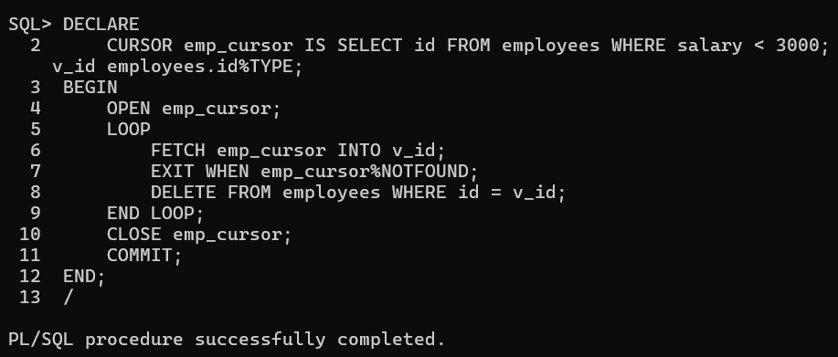

**Explanation:** Deletes employees earning less than 3000.

## Example 4: Update Salaries Using LOOP

DECLARE

CURSOR emp_cursor IS SELECT id FROM employees; v_id employees.id%TYPE;

BEGIN

OPEN emp_cursor;

LOOP

FETCH emp_cursor INTO v_id;

EXIT WHEN emp_cursor%NOTFOUND;

UPDATE employees SET salary = salary + 1000 WHERE id = v_id;

END LOOP;

CLOSE emp_cursor;

COMMIT;

END;

/

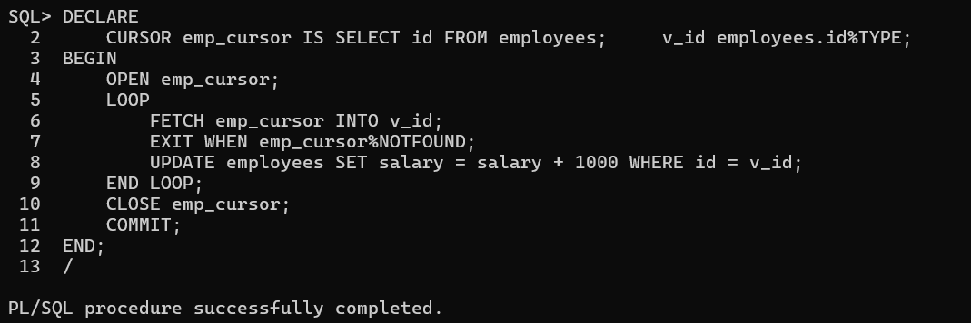

**Explanation:** Increases salaries by 1000 for all employees.

# WHILE LOOP (Executes as long as the condition is TRUE)

**Example 1: Print Employee Names While ID ≤ 5** DECLARE v_id NUMBER := 1; v_name employees.name%TYPE;

BEGIN

WHILE v_id <= 5 LOOP

SELECT name INTO v_name FROM employees WHERE id = v_id; DBMS_OUTPUT.PUT_LINE('Employee: ' || v_name); v_id := v_id + 1;

END LOOP;

END;

/

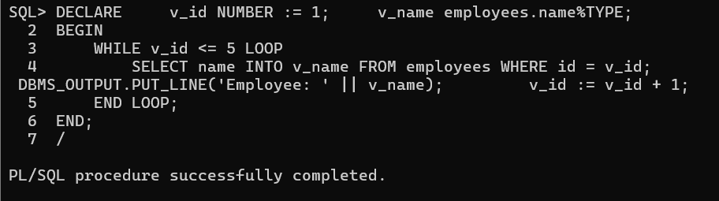

**Explanation:** Fetches and prints employee names for IDs 1 to 5.

## Example 2: Insert Employees Until a Certain Count

DECLARE v_count NUMBER := 0;

BEGIN

WHILE v_count < 5 LOOP

INSERT INTO employees (id, name, salary) VALUES (v_count + 10,

'New_Employee', 4000); v_count := v_count + 1;

END LOOP;

COMMIT;

END;

/

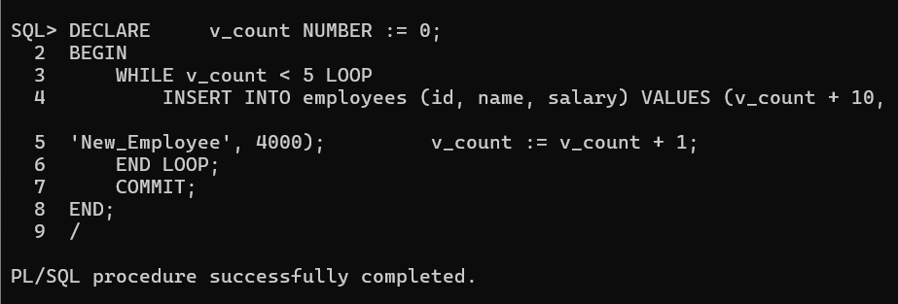

**Explanation:** Inserts 5 new employees.

## Example 3: Fetch and Display Employees with Salary Above 6000

DECLARE

CURSOR emp_cursor IS SELECT name FROM employees WHERE salary >

6000; v_name employees.name%TYPE;

BEGIN

OPEN emp_cursor;

FETCH emp_cursor INTO v_name;

WHILE emp_cursor%FOUND LOOP

DBMS_OUTPUT.PUT_LINE('Employee: ' || v_name);

FETCH emp_cursor INTO v_name;

END LOOP;

CLOSE emp_cursor;

END;

/

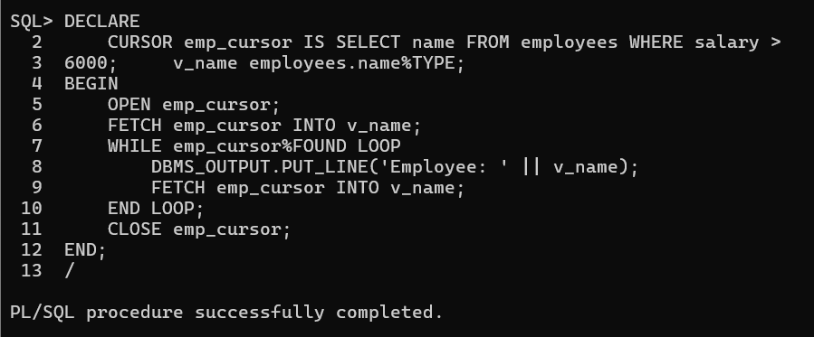

**Explanation:** Fetches employees earning more than 6000.

## Example 4: Deduct Salary Until Minimum Threshold DECLARE v_salary NUMBER;

BEGIN

SELECT salary INTO v_salary FROM employees WHERE id = 1;

WHILE v_salary > 3000 LOOP

UPDATE employees SET salary = salary - 500 WHERE id = 1; v_salary := v_salary - 500;

END LOOP;

COMMIT;

END;

/

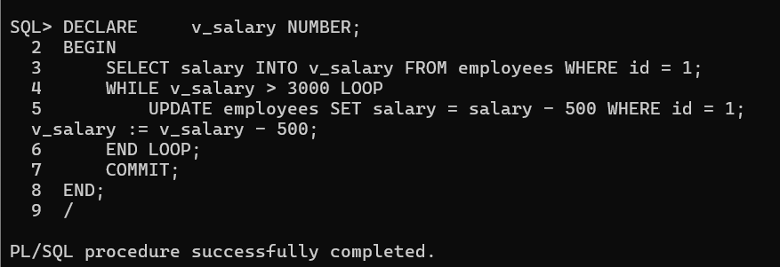

**Explanation:** Deducts salary until it reaches 3000.

# FOR LOOP (Counter-based loop, runs a fixed number of times)

## Example 1: Insert 10 Employees Using FOR LOOP

BEGIN

FOR i IN 1..10 LOOP

INSERT INTO employees (id, name, salary) VALUES (i + 100,

'Emp_' || i, 6000);

END LOOP;

COMMIT;

END;

/

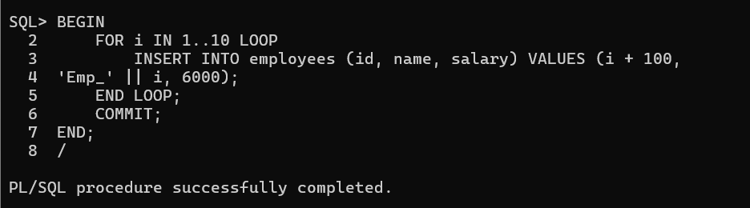

**Explanation:** Inserts 10 employees with unique IDs.

## Example 2: Display First 5 Employees

BEGIN

FOR emp IN (SELECT name FROM employees WHERE ROWNUM <= 5) LOOP DBMS_OUTPUT.PUT_LINE('Employee: ' || emp.name);

END LOOP;

END;

/

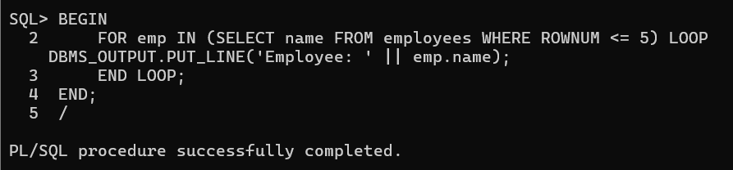

**Explanation:** Prints the first 5 employee names.

## Example 3: Increase Salaries in a Range

BEGIN

FOR i IN 1..10 LOOP

UPDATE employees SET salary = salary + 500 WHERE id = i;

END LOOP;

COMMIT;

END;

/

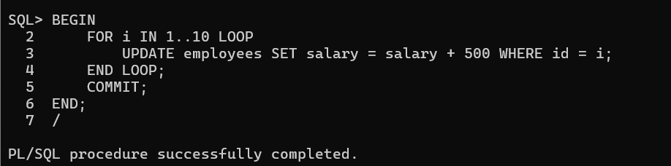

**Explanation:** Increases salaries of employees with IDs 1 to 10.

## Example 4: Delete Employees with ID Greater Than 50

BEGIN

FOR i IN (SELECT id FROM employees WHERE id > 50) LOOP DELETE FROM employees WHERE id = i.id;

END LOOP;

COMMIT;

END;

/

**Explanation:** Deletes employees with IDs greater than 50.

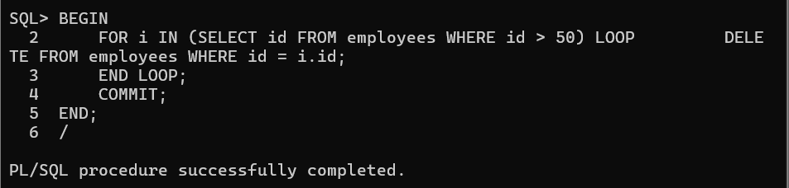

# Loops with database Simple Tasks for Practice

1. Write a **LOOP** to insert **5 new departments** into a departments table.

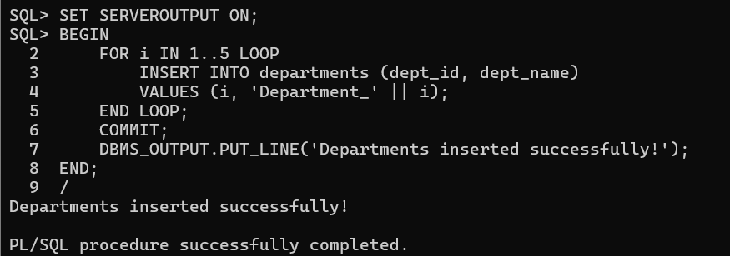

1. Modify the **WHILE LOOP** to **increase salaries** until they reach 10,000.

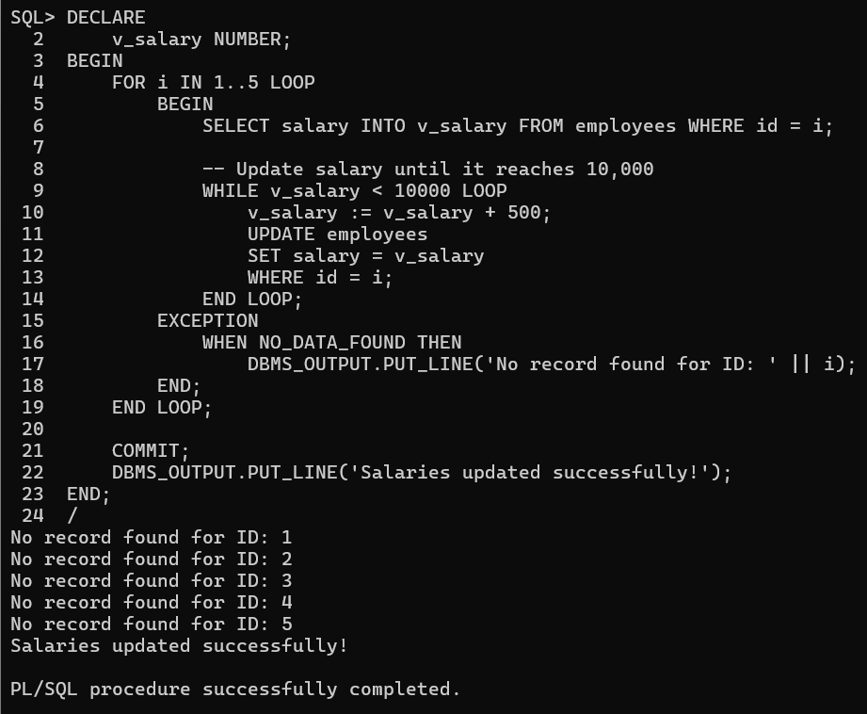

1. Write a **FOR LOOP** to display **employee details** for IDs 1 to 5.

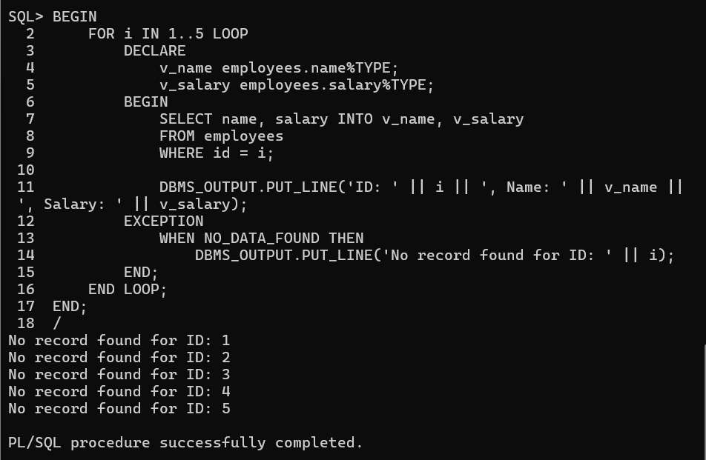

1. Create a **cursor-based LOOP** that prints **employee names and salaries**.

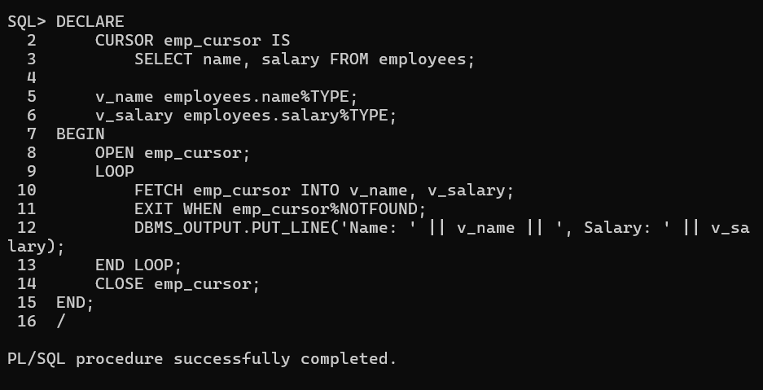

1. Write a loop that **calculates the total salary** of all employees.

